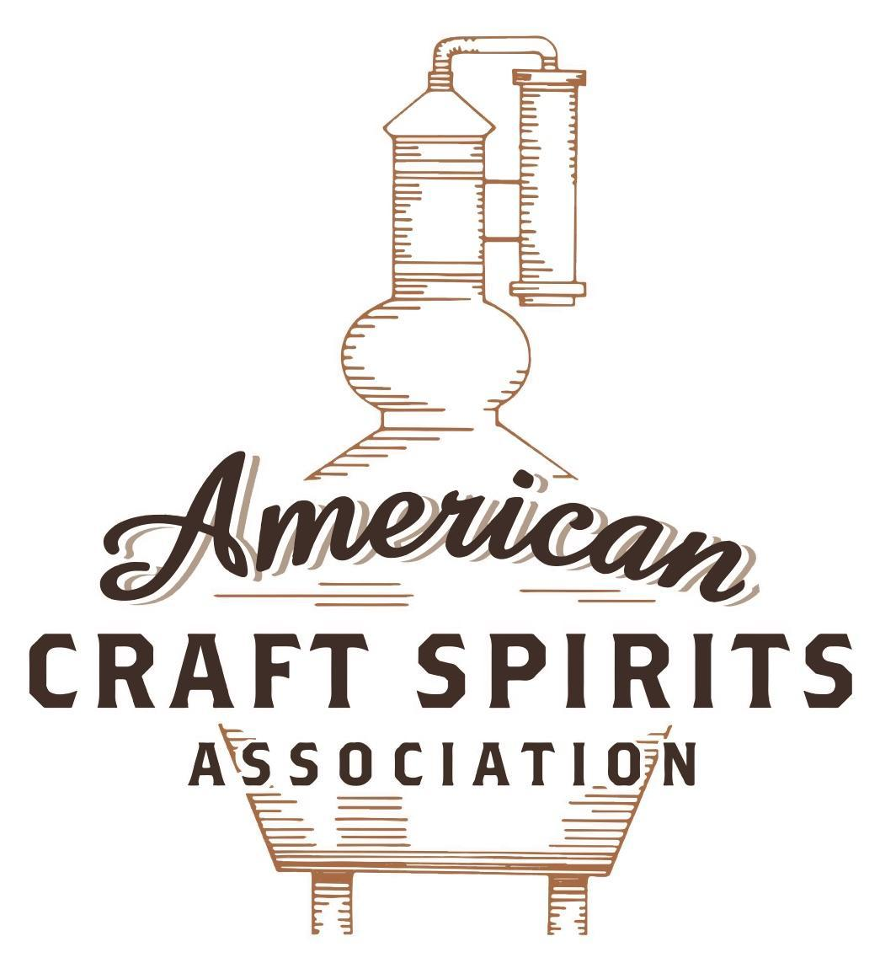
Spirits DtC Shipping Guide

This guide summarizes the direct-to-consumer shipping rules for distilleries in all 50 states and D.C. and also addresses the measures state governments have taken to ease delivery and shipping restrictions during the COVID-19 pandemic.

DtC Quick Guide Comparison

Out-of-State Distilleries  Can Ship Into State? |  |  |  | In-State Distilleries  Can Ship Within State?
State | Yes | No |  | State | Yes | No
AL |  | X |  | AL |  | X
AK | X |  |  | AK | X
AZ | X |  |  | AZ | X
AR |  | X |  | AR |  | X
CA |  | X* |  | CA |  | X*
CO |  | X |  | CO |  | X
CT |  | X* |  | CT |  | X
DE |  | X |  | DE |  | X
DC | X |  |  | DC | X
FL |  | X |  | FL |  | X
GA |  | X |  | GA |  | X
HI |  | X* |  | HI |  | ?*
ID |  | X |  | ID |  | X
IL |  | X* |  | IL |  | X*
IN |  | X |  | IN |  | X
IA |  | X* |  | IA |  | X*
KS |  | X |  | KS |  | X
KY | X |  |  | KY | X
LA |  | X |  | LA |  | X
ME |  | X* |  | ME |  | X*
MD |  | X |  | MD |  | X
MA |  | X |  | MA |  | X
MI |  | X |  | MI |  | X
MN |  | X |  | MN |  | X
MS |  | X |  | MS |  | X
MO |  | X |  | MO |  | X
MT |  | X |  | MT |  | X
NE | X |  |  | NE | X
NV |  | X* |  | NV |  | X
NH | X |  |  | NH |  | X*
NJ |  | X* |  | NJ |  | X*
NM |  | X |  | NM |  | X
NY |  | X* |  | NY |  | X*
NC |  | X |  | NC |  | X
ND | X |  |  | ND | X
OH |  | X |  | OH |  | X
OK |  | X |  | OK |  | X
OR |  | X |  | OR | X
PA |  | X* |  | PA |  | X
RI |  | X* |  | RI |  | X
SC |  | X |  | SC |  | X
SD |  | X |  | SD |  | X
TN |  | X |  | TN |  | X
TX |  | X |  | TX |  | X
UT |  | X |  | UT |  | X
VT |  | X |  | VT |  | X
VA |  | X |  | VA |  | X
WA |  | X* |  | WA | X
WV |  | X* |  | WV |  | X*

WI |  | X |  | WI |  | X
WY |  | X |  | WY |  | X

Notes:
*CA: If passed and signed into law, Senate Bill 620 would allow licensed distilled spirits producers in states other than California and licensed distilled spirits manufacturers or craft distillers in California who obtain distilled spirits direct shipper permits to ship directly to consumers in California
*CT: Consumers with appropriate permit may receive alcohol shipments
*HI: Consumers with appropriate permit may receive alcohol shipments; If passed and signed into law, Senate Bill 65 would allow licensed distilled spirits manufacturers in Hawaii and in states other than Hawaii who obtain direct shipper permits to ship directly to consumers in Hawaii
*IL: If passed and signed into law, Senate Bill 0532 would allow licensed distilled spirits producers in Illinois and in states other than Illinois who obtain distillery shippers’ licenses to ship directly to consumers in Illinois
*IA: If passed and signed into law, House File 639 would allow native distilled spirits manufacturers in Iowa and in states other than Iowa who obtain direct shipper permits to ship directly to consumers in Iowa and to consumers in states other than Iowa
*ME: If passed and signed into law, Legislative Document 1358 would allow distilleries outside of Maine with current manufacturer licenses and distilleries licensed in Maine who obtain spirits direct shipper licenses to ship directly to consumers in Maine
*NJ: (1) If passed and signed into law, Assembly Bill 3167 would allow a craft distillery licensees to ship no more than 9 liters of distilled spirits to a consumer in New Jersey; (2) If passed and signed into law, Senate Bill 3020 would allow craft distillery licensees in New Jersey or in states other than New Jersey to ship no more than 20 liters of distilled spirits to a consumer in New Jersey via common carrier
*NV: Licensed individuals can import one gallon per month of spirits for personal use and the out-of-state supplier must pay excise tax
*NH: If passed and signed into law, Senate Bill 125 would allow licensed liquor manufacturers who obtain direct to consumer shipping permits from the commission to ship directly to consumers in New Hampshire
*NY: Consumer may import up to 90L of liquor per year for personal use without a license; If passed and signed into law, Assembly Bill 3275 would allow licensed liquor manufacturers in states other than New York and licensed distillers and farm distillers in New York to ship no more than thirty-six cases (no more than nine liters per case) of liquor to consumers in New York
*PA: Consumer may place a special liquor order and distiller must ship to a PLCB-operated store
*RI: Distiller can only ship to customer if order was personally placed by customer at distiller's premises
*WA: If passed and signed into law, House Bill 1432 would allow licensed spirits manufacturers in states other than Washington to ship spirits to consumers in Washington
*WV: Distilleries, mini-distilleries, or micro-distilleries licensed in West Virginia or a state other than West Virginia who obtain private direct shipper licenses to ship to a consumer in West Virginia, however the shipments must be made to a retail liquor outlet

INDIANA
Shipment Outbound – Yes, a distiller may sell and deliver liquor to points outside IN (IC 7.1-3-7-3). A distiller also may sell and ship to a place outside IN liquor manufactured by another distiller under IC 7.1-3-7-5.
Shipment Inbound – No, only direct wine seller permittees may ship to a person in IN who does not hold a valid wholesaler permit (IC 7.1-5-11-1.5(a)).
Shipment Intra-state – No, a distiller may not sell liquor to a consumer (IC 7.1-3-7-3).
COVID-19 Measures – Executive Order 20-44 extends Executive Order 20-14, which allows permittees not otherwise eligible for carryout, to sell alcoholic beverages for carryout and allows permittees to take alcohol to a vehicle adjacent to a restaurant premises until December 1, 2020. Executive Order 21-12 extended Executive Order 20-14 until May 31, 2021. On April 29, 2021 these provisions were made permanent when H.B. 1396 was signed and enacted into law.
Executive Order 21-12 Link: https://www.in.gov/gov/files/Executive-Order-21-12-Continuation-of-Modified-County-Based-Restrictions.pdf
H.B. 1396 Link: https://legiscan.com/IN/text/HB1396/id/2238613/Indiana-2021-HB1396-Introduced.pdf
Citation (shipment)
Indiana Code
IC 7.1-3-7-3 Scope of permit
Sec. 3. (a) The holder of a distiller’s permit shall be entitled to:
(1) manufacture liquor;
(2) rectify liquor;
(3) bottle liquor; and
(4) insert liquor into containers.
(b) A distiller shall enjoy all the privileges accorded the holder of a rectifier’s permit, but the distiller shall not have to obtain a separate rectifier’s permit nor pay an additional fee.
(c) A distiller shall be entitled to transport liquor and to sell and deliver it in shipments to points outside this state, or to the holder of a liquor wholesaler’s permit, or to the holder of a rectifier’s permit.
(d) A distiller may not sell liquor produced under a distiller’s permit as issued under section 1 of this chapter to a consumer, nor to a person for the purpose of having it retailed by the person, whether that person holds a liquor retailer’s permit under this title or not.
(e) A distiller may transport liquor to and from a brewery located within the same county for the purposes of carbonating and canning by the brewery.
(f) The activity under this section is not an interest under IC 7.1-5-9.
Link: http://184.175.130.101/legislative/laws/2021/ic/titles/7.1#7.1-3-7-3
IC 7.1-3-7-5 Importation of liquor by distiller
Sec. 5. Importation of Liquor by Distiller. The holder of a distiller’s permit also shall be entitled to import and sell within this state liquor fully manufactured outside this state and ready for marketing when imported. A distiller may sell imported liquor only to a person who holds a liquor wholesaler’s permit, or to the holder of a rectifier’s permit, or to another distiller. A distiller may not sell imported liquor at retail nor to a retailer. A distiller also may sell and ship to a place outside this state, the liquor manufactured by another distiller under this title.
Link: http://184.175.130.101/legislative/laws/2021/ic/titles/7.1#7.1-3-7-5
IC 7.1-5-11-1.5 Shipments of alcoholic beverages to residents without valid wholesaler permits; violations
Sec. 1.5. (a) Except as provided in IC 7.1-3-26, it is unlawful for a person in the business of selling alcoholic beverages in Indiana or outside Indiana to ship or cause to be shipped an alcoholic beverage directly to a person in Indiana who does not hold a valid wholesaler permit under this title. This includes the ordering and selling of alcoholic beverages over a computer network (as defined by IC 35-43-2-3(a)).
(b) An in-state or an out-of-state vintner, distiller, brewer, rectifier, or importer that:
(1) holds a basic permit from the federal Bureau of Alcohol, Tobacco, Firearms and Explosives; and
(2) knowingly violates subsection (a);
commits a Class A misdemeanor.
(c) A person who is not an in-state or an out-of-state vintner, distiller, brewer, rectifier, or importer that holds a basic permit from the federal Bureau of Alcohol, Tobacco, Firearms and Explosives who knowingly violates subsection (a) commits a Level 6 felony.
(d) Upon a determination by the commission that a person has violated subsection (a), a wholesaler may not accept a shipment of alcoholic beverages from the person for a period of up to one (1) year as determined by the commission.
(e) If the chairman of the alcohol and tobacco commission or the attorney general determines that a vintner, distiller, brewer, rectifier, or importer that holds a basic permit from the federal Bureau of Alcohol, Tobacco, Firearms and Explosives has made an illegal shipment of an alcoholic beverage to consumers in Indiana, the chairman shall:
(1) notify the federal Bureau of Alcohol, Tobacco, Firearms and Explosives in writing and by certified mail of the official determination that state law has been violated; and
(2) request the federal bureau to take appropriate action.
(f) The commission shall adopt rules under IC 4-22-2 to implement this section.
Link: http://184.175.130.101/legislative/laws/2021/ic/titles/7.1#7.1-5-11-1.5
Citation (COVID-19)
Sept. 28, 2020 - Information on Executive Order 20-43 and 20-44, Back on Track Indiana: Stage Five Previously issued capacity limits for restaurants, bars, taverns, nightclubs and other establishments providing in-person food and/or drink service have been rescinded and replaced with the following requirements:
all patrons must remain seated while consuming food and/or drink or when otherwise remaining on the premises; and seating must be arranged and maintained so that individuals, households or parties are spaced at least six feet apart from any other individual, household or party.
Self-service beverage stations are permitted and self-service food stations (buffets, salad bars, etc.) are permitted but not recommended unless a staff member serves patrons.
EO 20-44 extends Executive Order 20-14, which allows permittees not otherwise eligible for carryout, to sell alcoholic beverages for carryout and allows permittees to take alcohol to a vehicle adjacent to a restaurant premises until December 1, 2020.
Link: https://www.in.gov/atc/2854.htm

The American Craft Spirits Association (ACSA) is working diligently to give our members and industry partners relevant, current updates on statutes and regulations impacting production, sale and distribution of spirits. With the declaration of the novel coronavirus (COVID-19) in early 2020, many states have issued temporary policy changes or longer-term modernization of alcohol beverage laws. State statutes, regulations created by the state alcohol regulatory authority, as well as any other relevant guidance provided by such authorities (such as advisories, opinions, bulletins, etc.) were reviewed in creation of this document. No city or county ordinances were reviewed. Distillers should be aware that even in states where direct shipping is permissible, always remember to avoid shipping to dry counties. Please consult with your state guild or alcohol beverage authority for the most up-to-date information. This content is intended for educational and informational purposes only. ACSA's pro bono law firm of Malkin Law P.A. provided the core content found in this comprehensive overview of the spirits distribution after COVID-19. It was completed in August 2021 and will be updated regularly. If you have updates you would like to provide, please send to legislation@americancraftspirits.org or directly to the law firm at: ryan@malkin.law / malkin.law. Thank you.

